

Capstone Project Report
Report 4 – Software Design Document

– Ho Chi Minh, October 2026 –

Table of Contents
I. Record of Changes 3
II. Software Design Document 4
1. System Design 4
1.1 System Architecture 4
1.2 Package Diagram 4
2. Database Design 4
3. Detailed Design 5
3.1 <Feature/Function Name1> 5
3.2 <Feature/Function Name2> 6

I. Record of Changes
Date | A*  M, D | In charge | Change Description
20/10/26 | A | Project team | Prepared DroneOps Intelligence Software Design Document for Review 2.
*A - Added M - Modified D - Deleted

II. Software Design Document

1. System Design

1.1 System Architecture
DroneOps Intelligence uses a Next.js/React Web application, an ASP.NET Core API, application services, EF Core/Npgsql persistence and PostgreSQL. A telemetry gateway supplies normalized MAVLink-derived samples, and SSE delivers authorized live updates. Backend adapters provide media storage, email and AI integration. Low-level UAV flight control remains external.
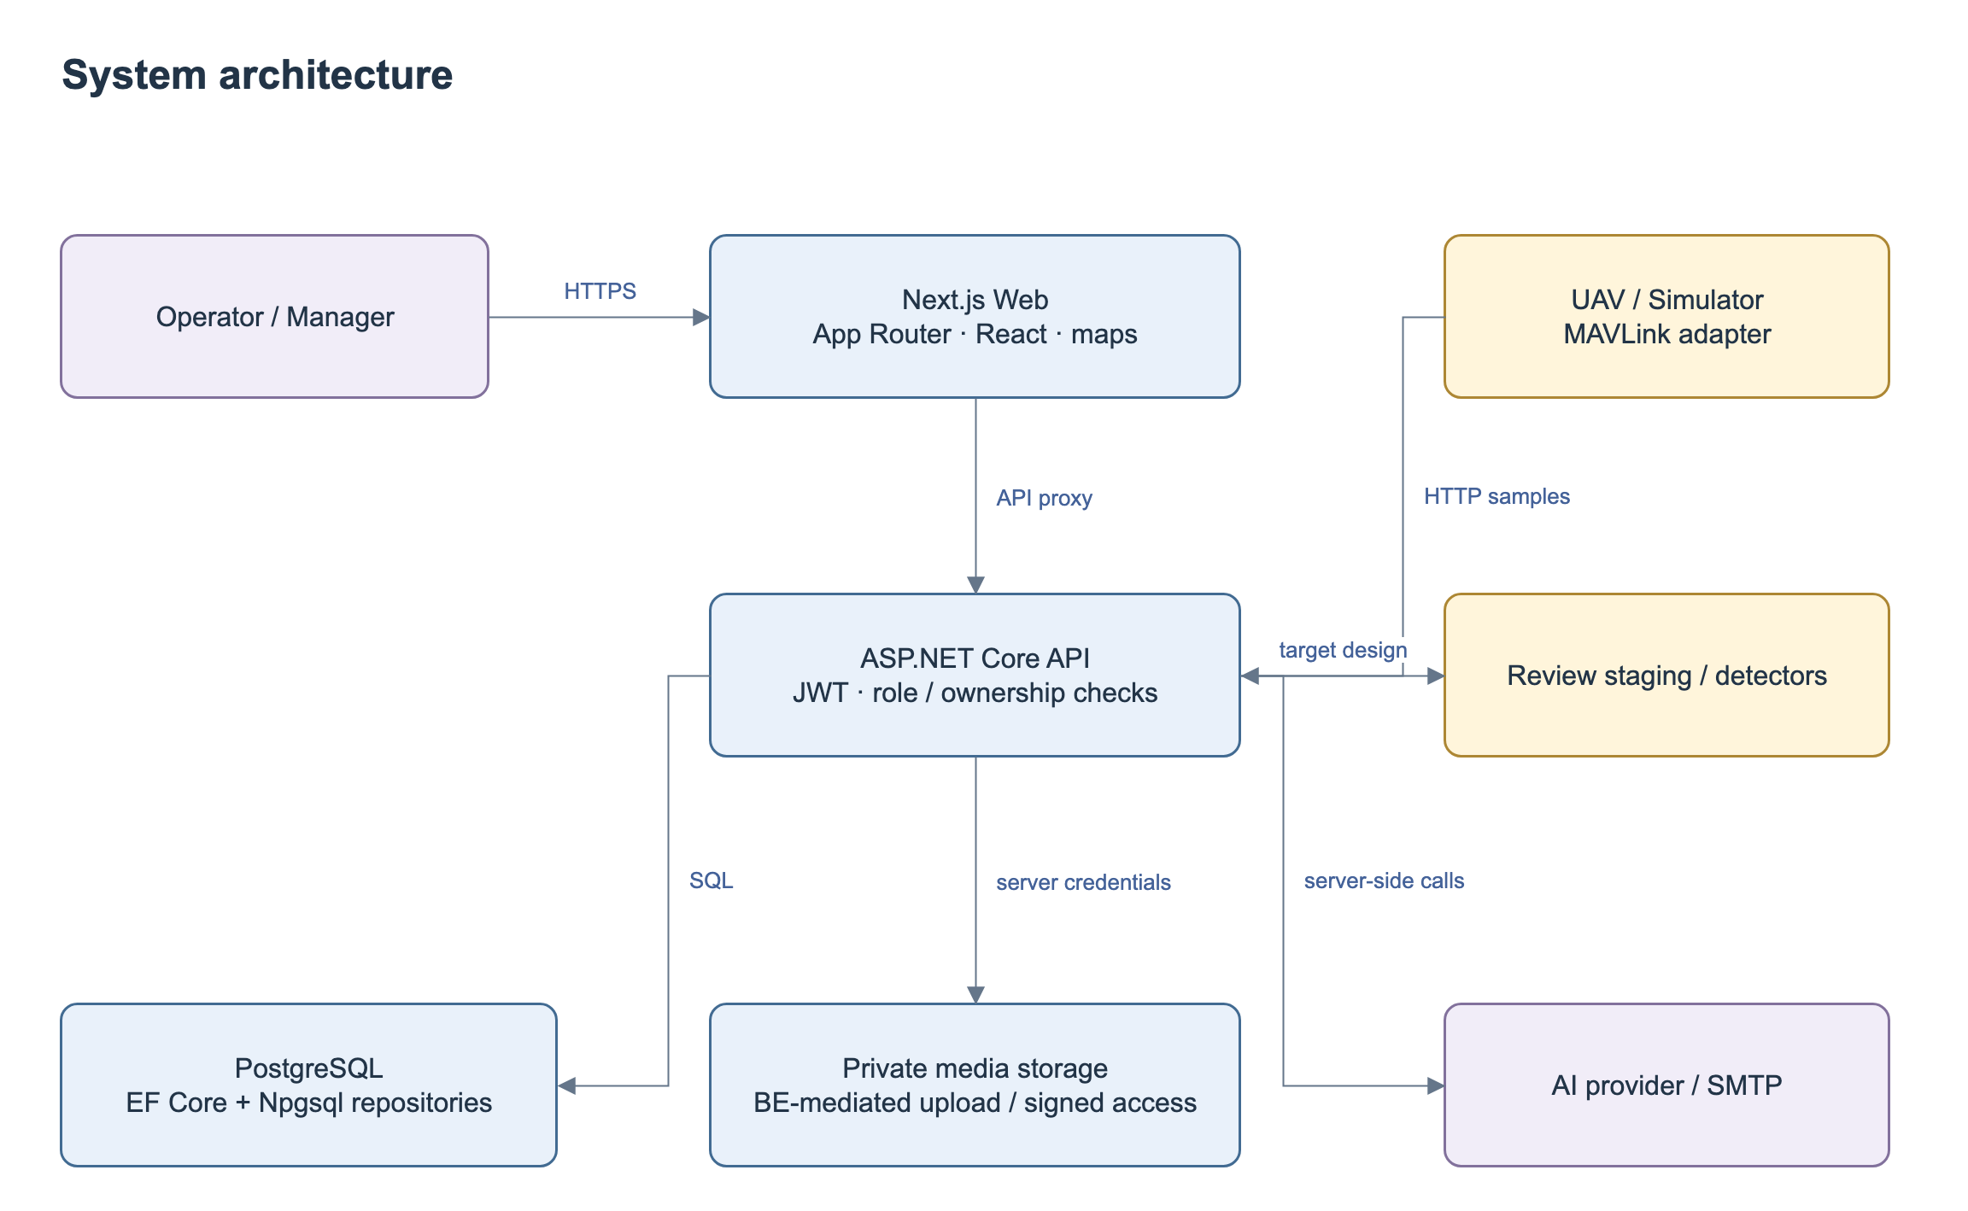
Figure 1. System Architecture.
No | Component | Description
1 | Next.js Web + proxy | Role-specific pages, client validation, map, same-origin forwarding. Backend remains authoritative for authorization and state.
2 | API + Application | JWT/canonical roles, DTO validation, business services and outcome errors. Controllers delegate business operations to services; the composition root configures persistence and external adapters.
3 | Persistence + Domain | EF entities/repositories plus Npgsql stores. Application depends on repository interfaces in Persistence and entities in Domain.
4 | PostgreSQL / media | Transactional domain records; proposed request/evidence storage. Private user media uses protected backend read/upload and short-lived access; no public server secret.
5 | Integration gateway / SSE | Normalized sample HTTP endpoint exists. Raw MAVLink adapter and background loss timer remain gaps; latest snapshot and SSE support frontend monitoring.
6 | External AI / email | Configured outbound calls with bounded timeout, provenance and error handling. AI advice cannot approve missions.

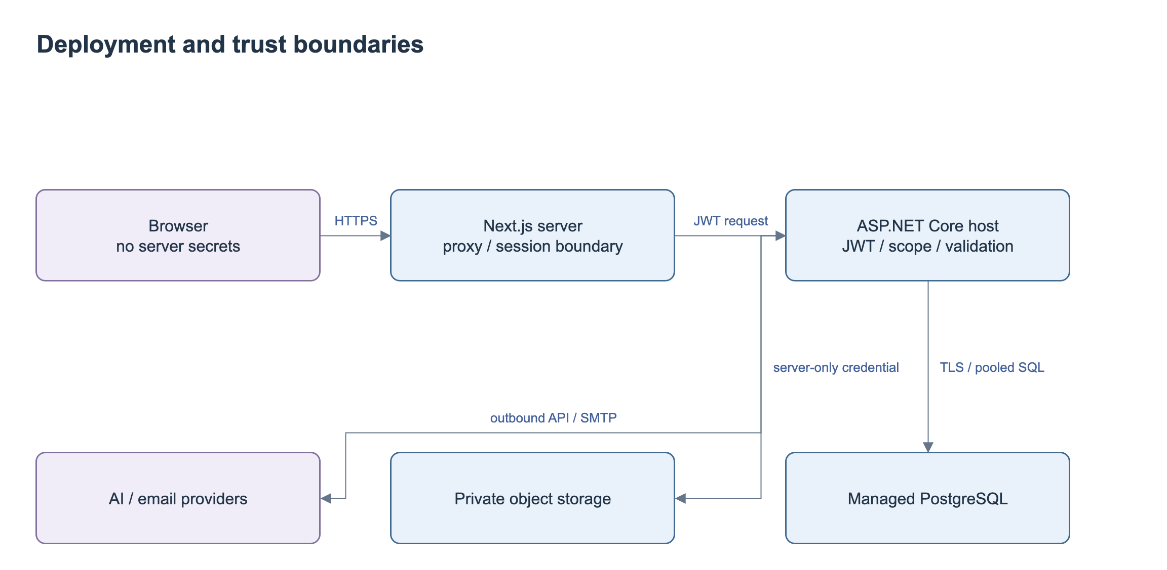
Figure 2. Deployment and Trust Boundaries.

1.2 Package Diagram
The backend packages separate API endpoints, application services, persistence and domain entities. The Web subsystem groups route components, shared clients and API forwarding.
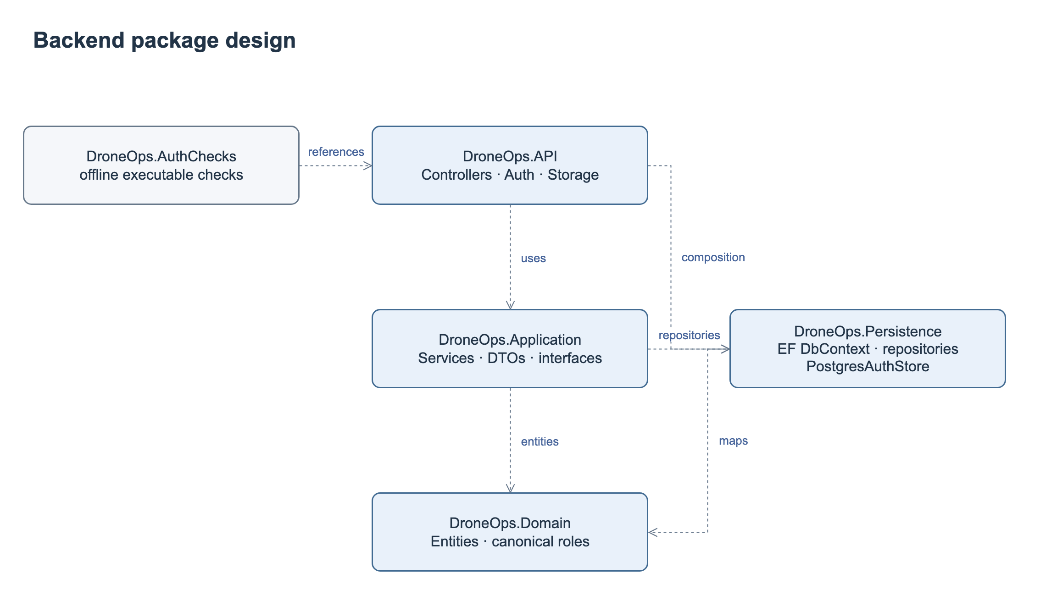
Figure 3. Backend Package Diagram.
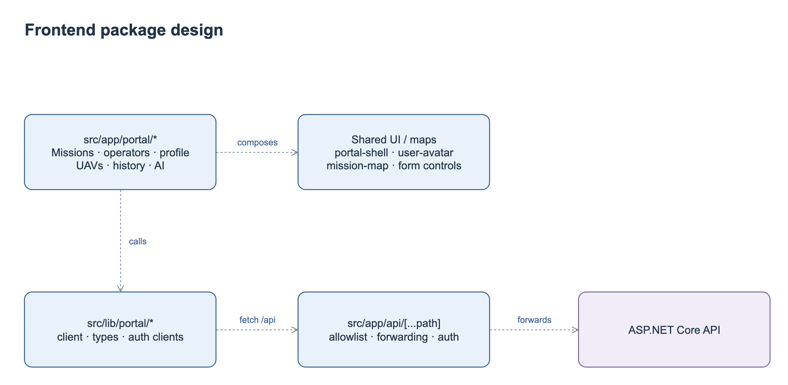
Figure 4. Web Package Diagram.
Package Descriptions
No | Package | Description
1 | DroneOps.API | Controllers/{Missions,Integrations,Incidents,Users,PostFlight}; authentication middleware, Storage helpers, composition root.
2 | DroneOps.Application | Services/{Missions,Telemetry,Incidents,PostFlight,AI,Auth}; request/response DTOs and service interfaces.
3 | DroneOps.Persistence | AppDbContext, repositories and interfaces; PostgresAuthStore; Npgsql pooling.
4 | DroneOps.Domain | Mission, Waypoint, UAV, User/Pilot, TelemetryRecord, Incident, MissionApproval, PostFlightReport and related records.
5 | DroneOps.AuthChecks | Executable offline authorization/validation checks; not a full database or end-to-end test suite.
6 | fe/src/app/portal | Mission/UAV/operator/profile/geofence/history/AI pages and shared shell/maps; monitoring/incident business screens still need integration.
7 | fe/src/lib + API proxy | Shared DTOs/clients and server forwarding; review allowlist and streaming timeout/buffering before realtime integration.

2. Database Design
The planning model stores the current mission and proposed updates awaiting review. Telemetry, incidents, review decisions, reports and assessments retain their mission relationships. Database keys and attributes are specified below.
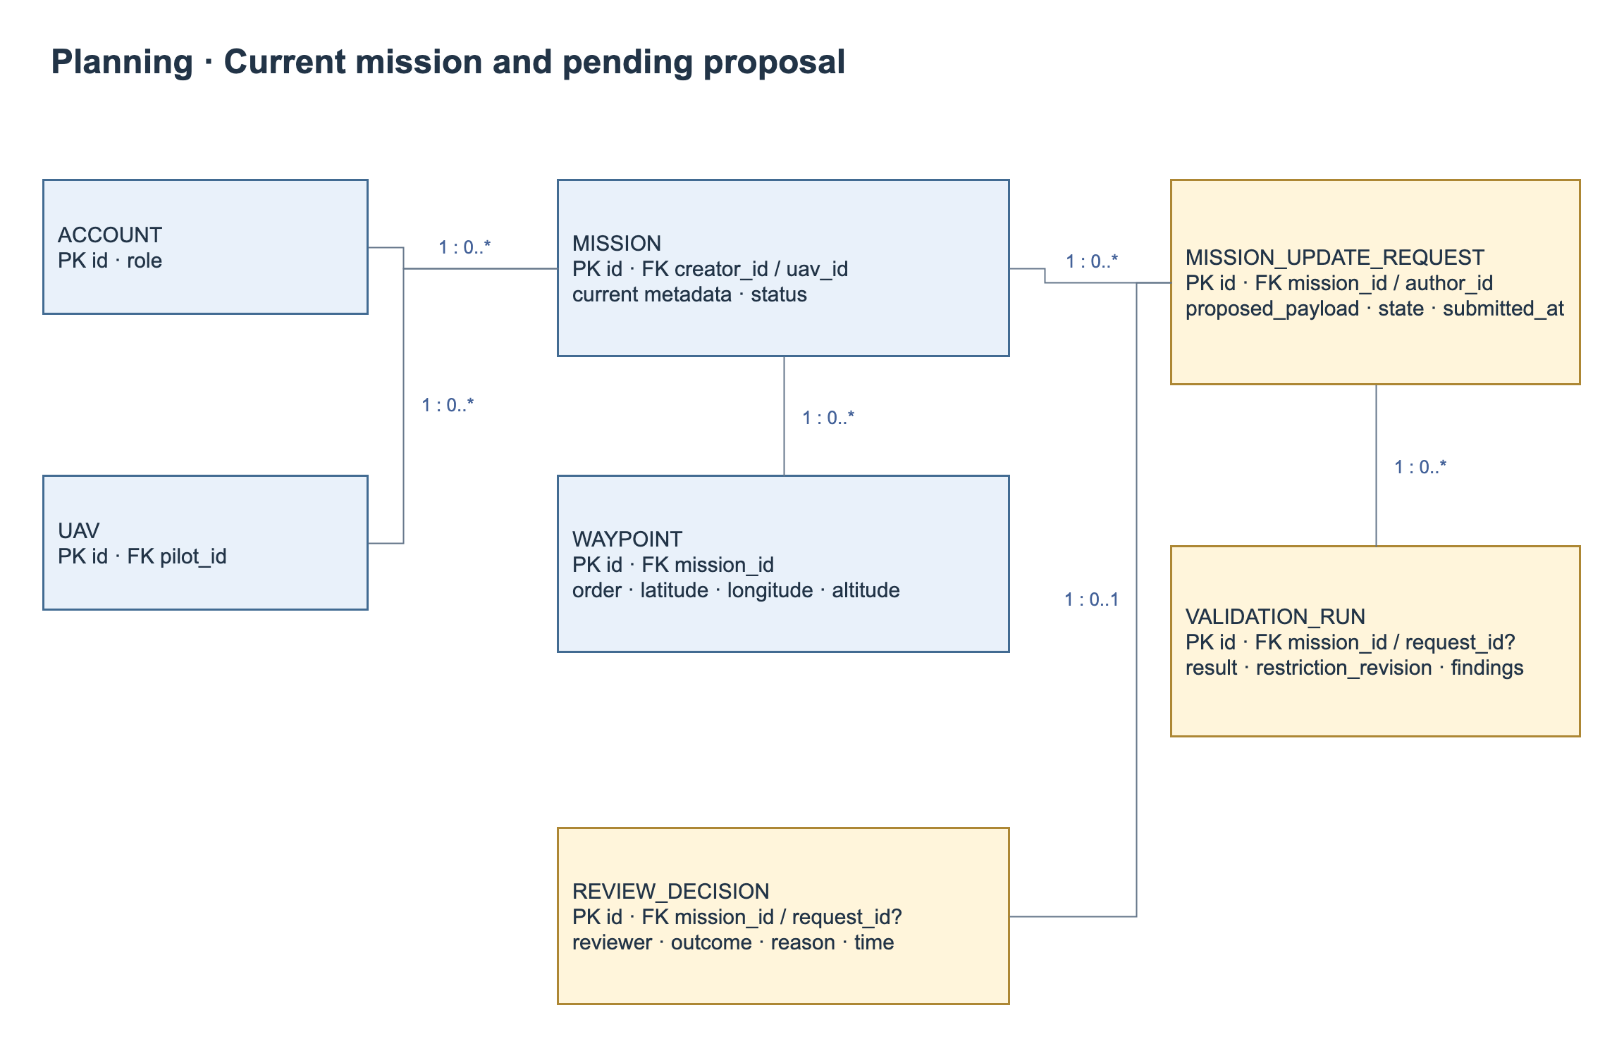
Figure 5. Planning and Approval Entity Relationship Diagram.
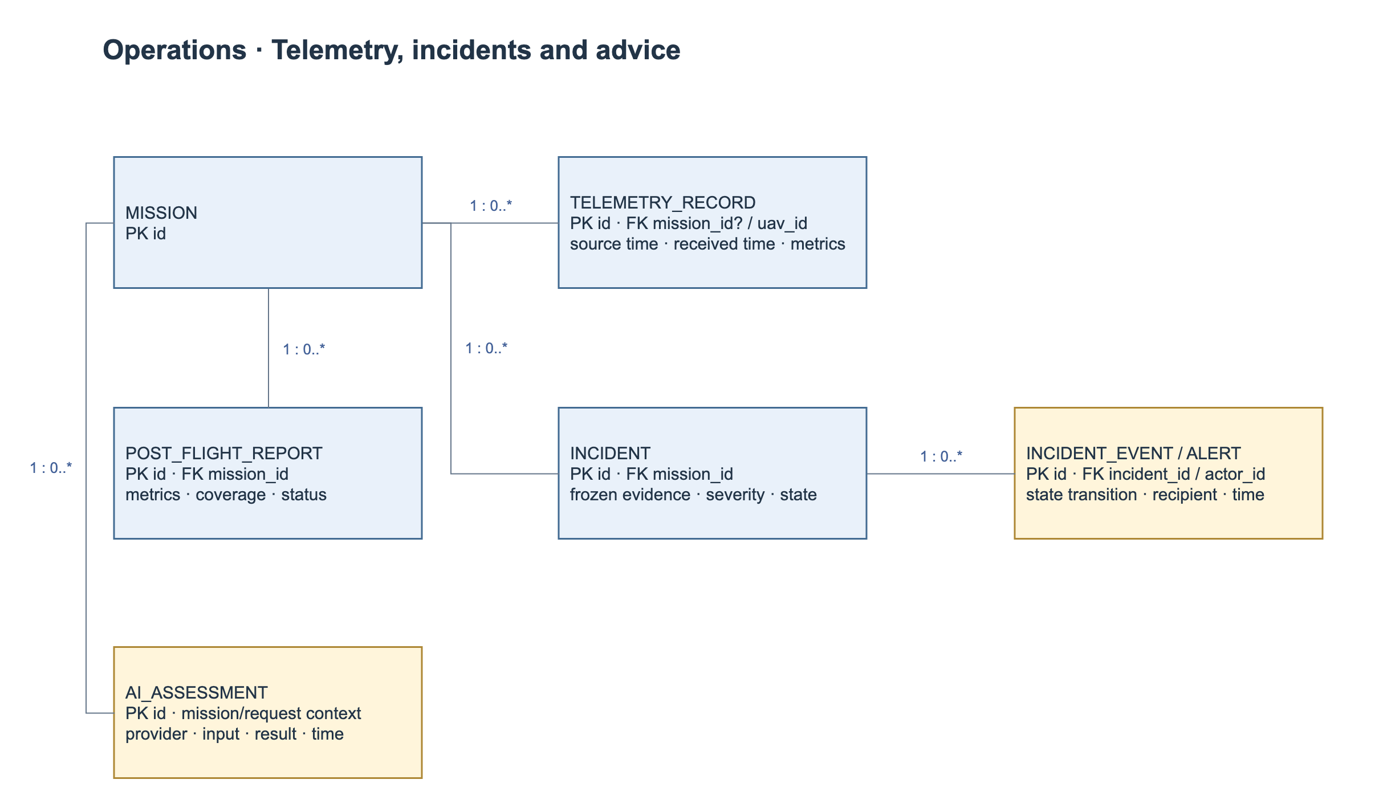
Figure 6. Telemetry, Incident and Assessment Entity Relationship Diagram.
Table Descriptions
No | Table | Description
1 | Geofence | Id: Guid; Name: string; Description: string?; Coordinates: string; CreatedAt: DateTime  Primary key: Id; reference fields: none in scalar fields.
2 | Incident | Id: Guid; MissionId: Guid; Title: string; Description: string?; Severity: string?; Type: string; Status: string; Latitude: decimal?; Longitude: decimal?; Evidence: string?; CreatedAt: DateTimeOffset; AcknowledgedAt: DateTimeOffset?; AcknowledgedBy: Guid?; ResolvedAt: DateTimeOffset?; ResolvedBy: Guid?; ResolutionNotes: string?  Primary key: Id; reference fields: MissionId.
3 | LicenseImage | Id: Guid; ImageUrl: string; ImageType: string?; CreatedAt: DateTime; PilotRegistrationId: Guid?; PilotUpdateRequestId: Guid?; PilotId: Guid?  Primary key: Id; reference fields: PilotRegistrationId, PilotUpdateRequestId, PilotId.
4 | Mission | Id: Guid; CreatedBy: Guid; UAVId: Guid?; Name: string; Description: string?; Status: string; StartTime: DateTime?; EndTime: DateTime?; CreatedAt: DateTime  Primary key: Id; reference fields: UAVId.
5 | MissionApproval | Id: Guid; MissionId: Guid; UserId: Guid; Status: string; Comment: string?; ApprovedAt: DateTimeOffset?  Primary key: Id; reference fields: MissionId, UserId.
6 | MissionSuggestion | Id: Guid; PilotId: Guid; Prompt: string; MissionName: string?; MissionPurpose: string?; SuggestedAltitude: decimal?; SuggestedWaypointCount: int?; SuggestedFlightDuration: int?; RiskAssessment: string?; Recommendations: string?; AiResponse: string; CreatedAt: DateTime  Primary key: Id; reference fields: PilotId.
7 | Pilot | Id: Guid; UserId: Guid; PhoneNumber: string?; DateOfBirth: DateOnly?; PilotLicenseNo: string; LicenseIssuedDate: DateOnly?; LicenseExpiredDate: DateOnly?; ExperienceYears: int; CreatedAt: DateTime  Primary key: Id; reference fields: UserId.
8 | PilotRegistration | Id: Guid; FullName: string; Email: string; PasswordHash: string; PhoneNumber: string?; DateOfBirth: DateOnly?; DroneType: string; DroneModel: string?; PilotLicenseNo: string; LicenseIssuedDate: DateOnly?; LicenseExpiredDate: DateOnly?; ExperienceYears: int?; UsagePurpose: string; Description: string?; Status: string; RejectReason: string?; ReviewedBy: Guid?; ReviewedAt: DateTime?; CreatedAt: DateTime  Primary key: Id; reference fields: none in scalar fields.
9 | PilotUpdateRequest | Id: Guid; PilotId: Guid; PilotLicenseNo: string; LicenseIssuedDate: DateOnly?; LicenseExpiredDate: DateOnly?; Status: string; RejectReason: string?; ReviewedBy: Guid?; ReviewedAt: DateTime?; CreatedAt: DateTime  Primary key: Id; reference fields: PilotId.
10 | PostFlightReport | Id: Guid; MissionId: Guid; TotalFlightDurationMinutes: double; MaxAltitude: decimal?; AvgAltitude: decimal?; MaxSpeed: decimal?; AvgSpeed: decimal?; InitialBatteryLevel: int?; FinalBatteryLevel: int?; BatteryConsumedPercentage: int?; TotalDistanceMeters: decimal?; TotalTelemetryRecords: int; TotalIncidents: int; Status: string; Summary: string?; SafetyEvaluation: string?; Notes: string?; CreatedAt: DateTimeOffset  Primary key: Id; reference fields: MissionId.
11 | Role | Id: Guid; Name: string; CreatedAt: DateTimeOffset  Primary key: Id; reference fields: none in scalar fields.
12 | TelemetryRecord | Id: Guid; SourceId: string?; UAVId: Guid; MissionId: Guid?; SourceTimestamp: DateTimeOffset; ReceivedAt: DateTimeOffset; RecordedAt: DateTimeOffset; Latitude: decimal?; Longitude: decimal?; Altitude: decimal?; AltitudeReference: string?; Speed: decimal?; BatteryLevel: int?; FlightMode: string?; Armed: bool; MissionSequence: int?; IdempotencyKey: string?; IsValid: bool  Primary key: Id; reference fields: UAVId, MissionId.
13 | UAV | Id: Guid; PilotId: Guid; Code: string; Name: string; Model: string?; Status: string; CreatedAt: DateTimeOffset  Primary key: Id; reference fields: PilotId.
14 | User | Id: Guid; AvatarPath: string?; RoleId: Guid; FullName: string; Email: string; PasswordHash: string; RequiresFirstLogin: bool; CreatedAt: DateTimeOffset  Primary key: Id; reference fields: RoleId.
15 | Waypoint | Id: Guid; MissionId: Guid; SequenceOrder: int; Latitude: decimal; Longitude: decimal; Altitude: decimal?; ActionType: string?; CreatedAt: DateTime  Primary key: Id; reference fields: MissionId.
16 | MissionUpdateRequest | Id UUID PK; MissionId and SubmittedBy references; ProposedPayload JSONB; Status; SubmittedAt; DecidedAt. The request stores complete pending changes. Request identity and atomic state checks prevent stale or repeated decisions from overwriting the current mission.
17 | ValidationRun / findings | Id PK; MissionId; nullable UpdateRequestId for initial/current review; input fingerprint; restriction revision; result/time; finding waypoint/segment/rule/reference. Evidence immutable, stale flag derived from changed inputs.
18 | Review decision link | Extend MissionApproval or add decision table: RequestId, ValidationRunId, reviewer/time/outcome/reason. Unique terminal decision per request; prior approval on current mission must not be downgraded on update rejection.
19 | IncidentEvent / Alert | Append-only transition and recipient delivery records; link IncidentId, actor/time/reason. Durable alerts for reconnect. Unique abnormal episode identity to deduplicate.
20 | Restriction metadata | Restriction type, altitude range, altitude reference and revision are supplied by the active restriction configuration and retained with each validation run.
21 | Flight identity / AI retrieval | Future schema decision: repeated execution identity and registered Top-k retrieval. Do not deploy empty Flight class or assume vector search exists.
The approval transaction checks the mission, request identity, record scope and current validation evidence before applying the accepted metadata and ordered waypoints. It records the decision and closes the request in the same transaction. Any failure rolls back the complete operation. Rejection updates only the request and decision, preserving current mission content and prior approval. A stale or conflicting request returns 409. Notification delivery follows the committed decision.
Indexes support ordered mission waypoints, pending requests, latest mission telemetry, incident status and recipient alerts. Ingestion uses an idempotency key, while decisions use a unique request identity and terminal-state check. Backend authorization protects mission, history, media and streaming operations.

3. Detailed Design

3.1 Mission Planning and Approval
This feature covers mission submission, pre-flight validation, proposed updates and Manager decisions. Approval applies accepted content to the same mission; rejection preserves current content and any existing approval.

3.1.1 Class Diagram
The classes below separate mission editing, proposed content, review decisions and the approval transaction.
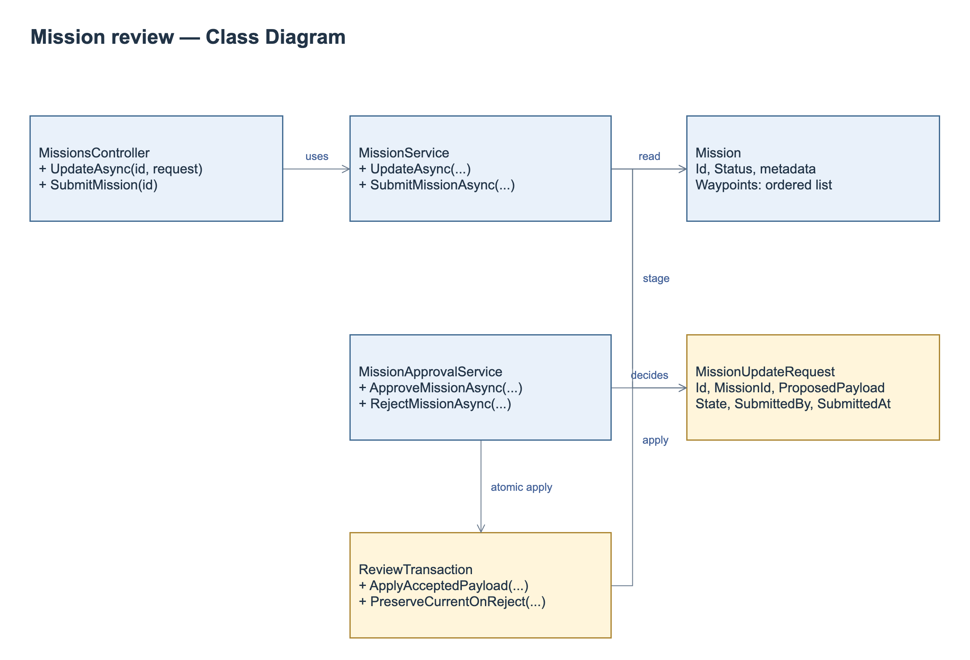
Figure 7. Mission Planning and Approval Class Diagram.
Class Specifications
No | Class / Operation | Specification
1 | MissionService.UpdateAsync | Input mission ID, authenticated operator and metadata/route. Authorize scope/state; reject malformed geometry; persist separate review request; run mandatory validation; return request ID/current mission summary. Current in-place update must be replaced.
2 | MissionUpdateRequest | Owns proposed payload, author/time and review state, not a mission version. Current content remains outside payload and authoritative.
3 | MissionApprovalService | Approve/reject exact request, require current evidence; commit accepted data atomically or reject without content mutation. Repeated/stale decisions return current outcome or conflict.
4 | Review transaction / validation | One DB unit of work, request identity, input fingerprint and restriction revision. Concurrent edits cannot reuse validation or overwrite a newer accepted proposal.

3.1.2 Submit a Mission Update
The Operator saves proposed changes. The service checks scope and mission state, stores the review request and validation outcome, and exposes the request to the Manager without overwriting the current mission.
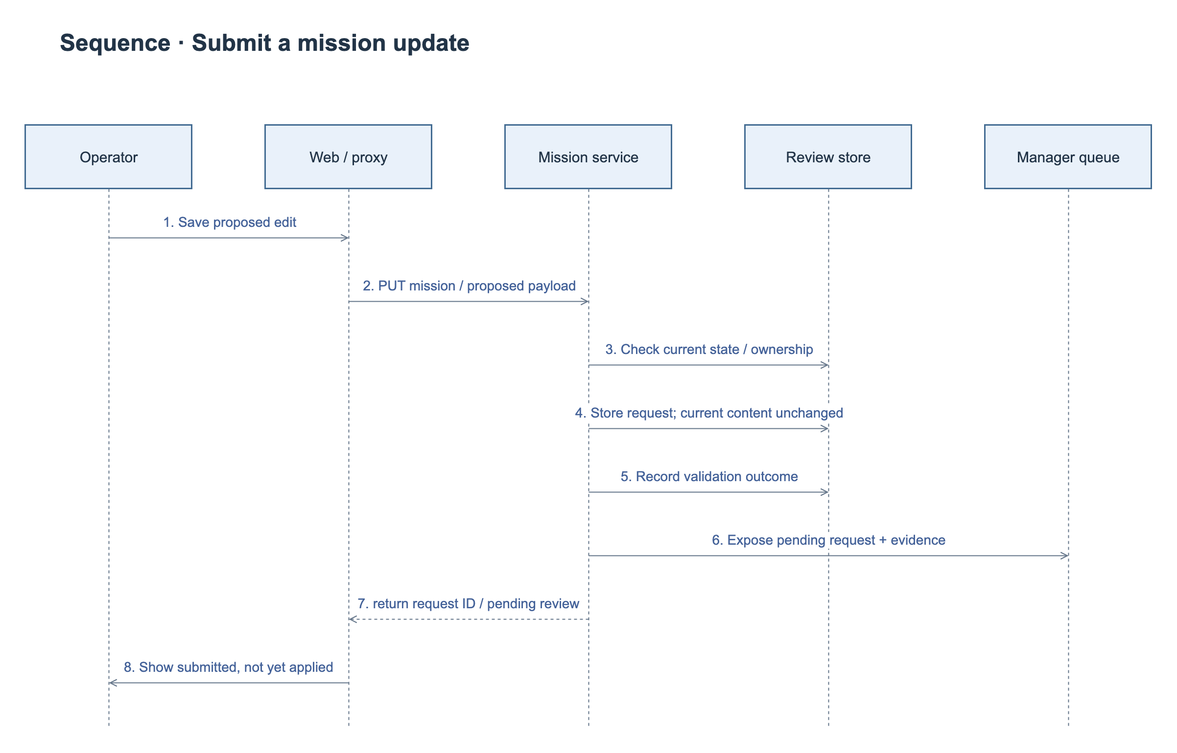
Figure 8. Submit Mission Update Sequence Diagram.

3.1.3 Approve a Mission Update
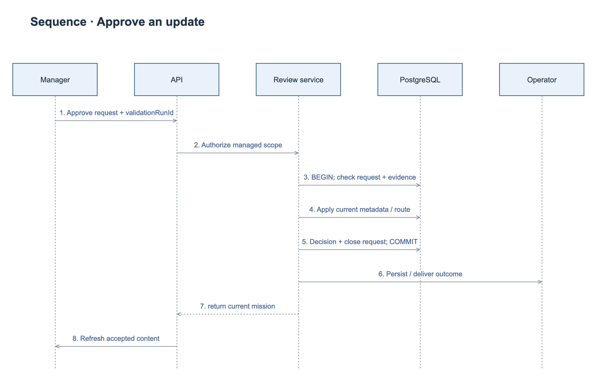
Figure 9. Approve Mission Update Sequence Diagram.

3.1.4 Reject a Mission Update
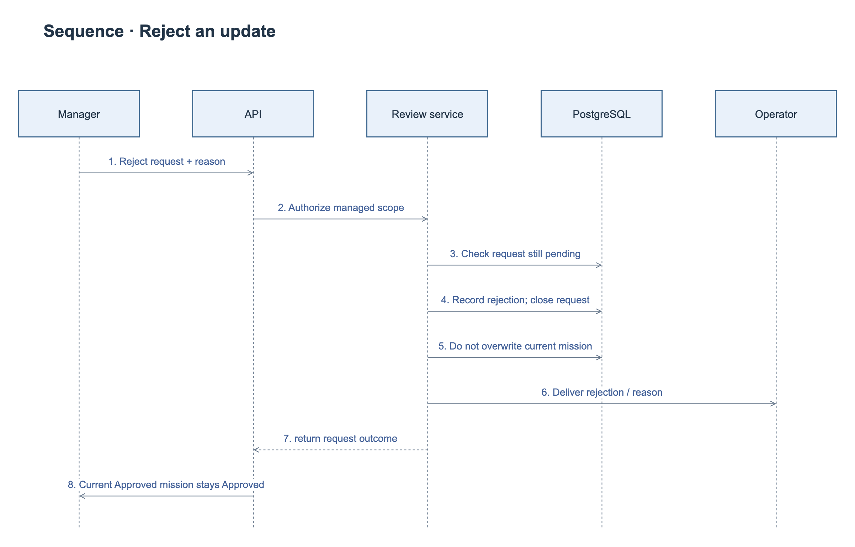
Figure 10. Reject Mission Update Sequence Diagram.
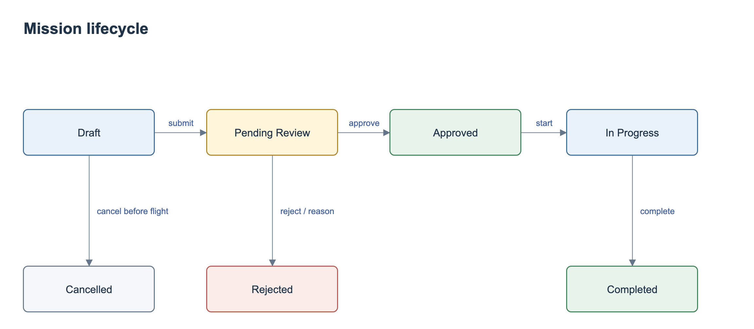
Figure 11. Mission State Diagram.
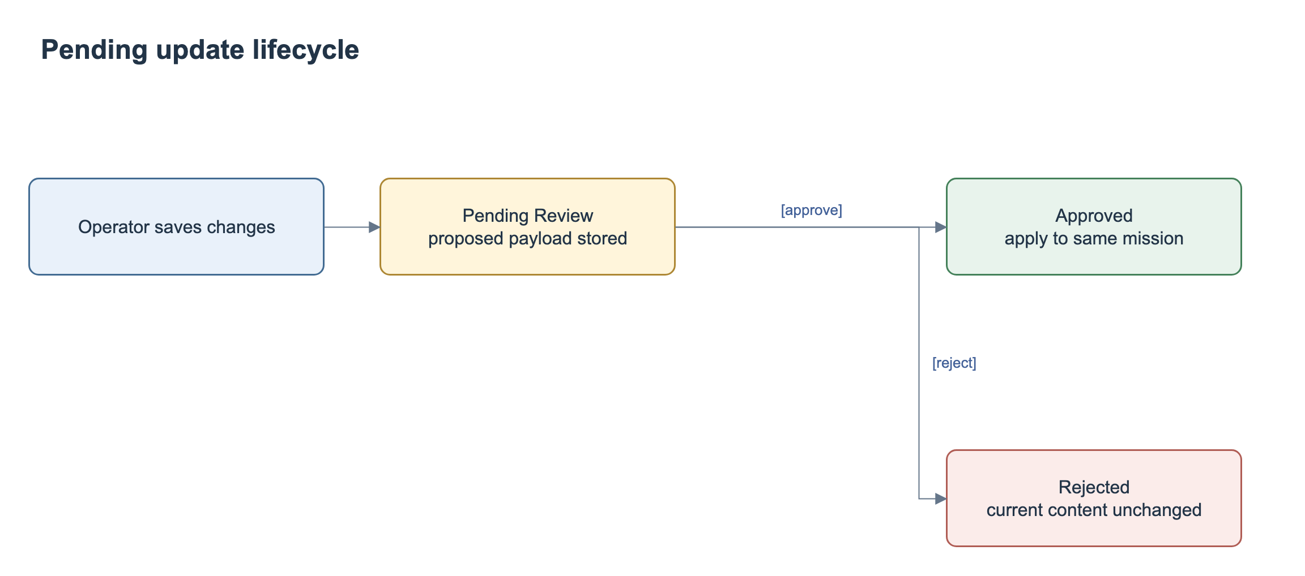
Figure 12. Mission Update Request State Diagram.
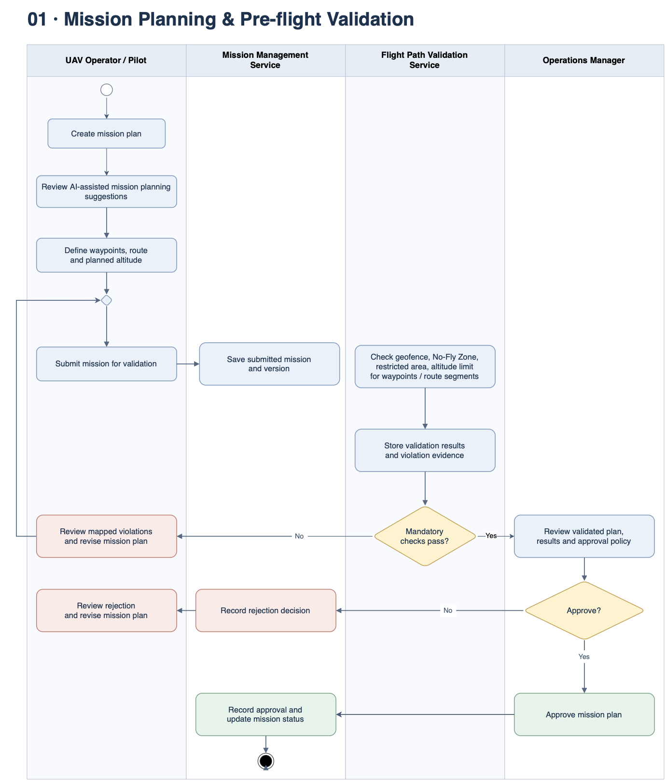
Figure 13. Mission Planning and Pre-flight Validation Workflow.

3.2 Realtime Monitoring and Incident Management
This feature receives timestamped telemetry, maintains the latest authorized mission state and records incident evidence and handling decisions.

3.2.1 Class Diagram
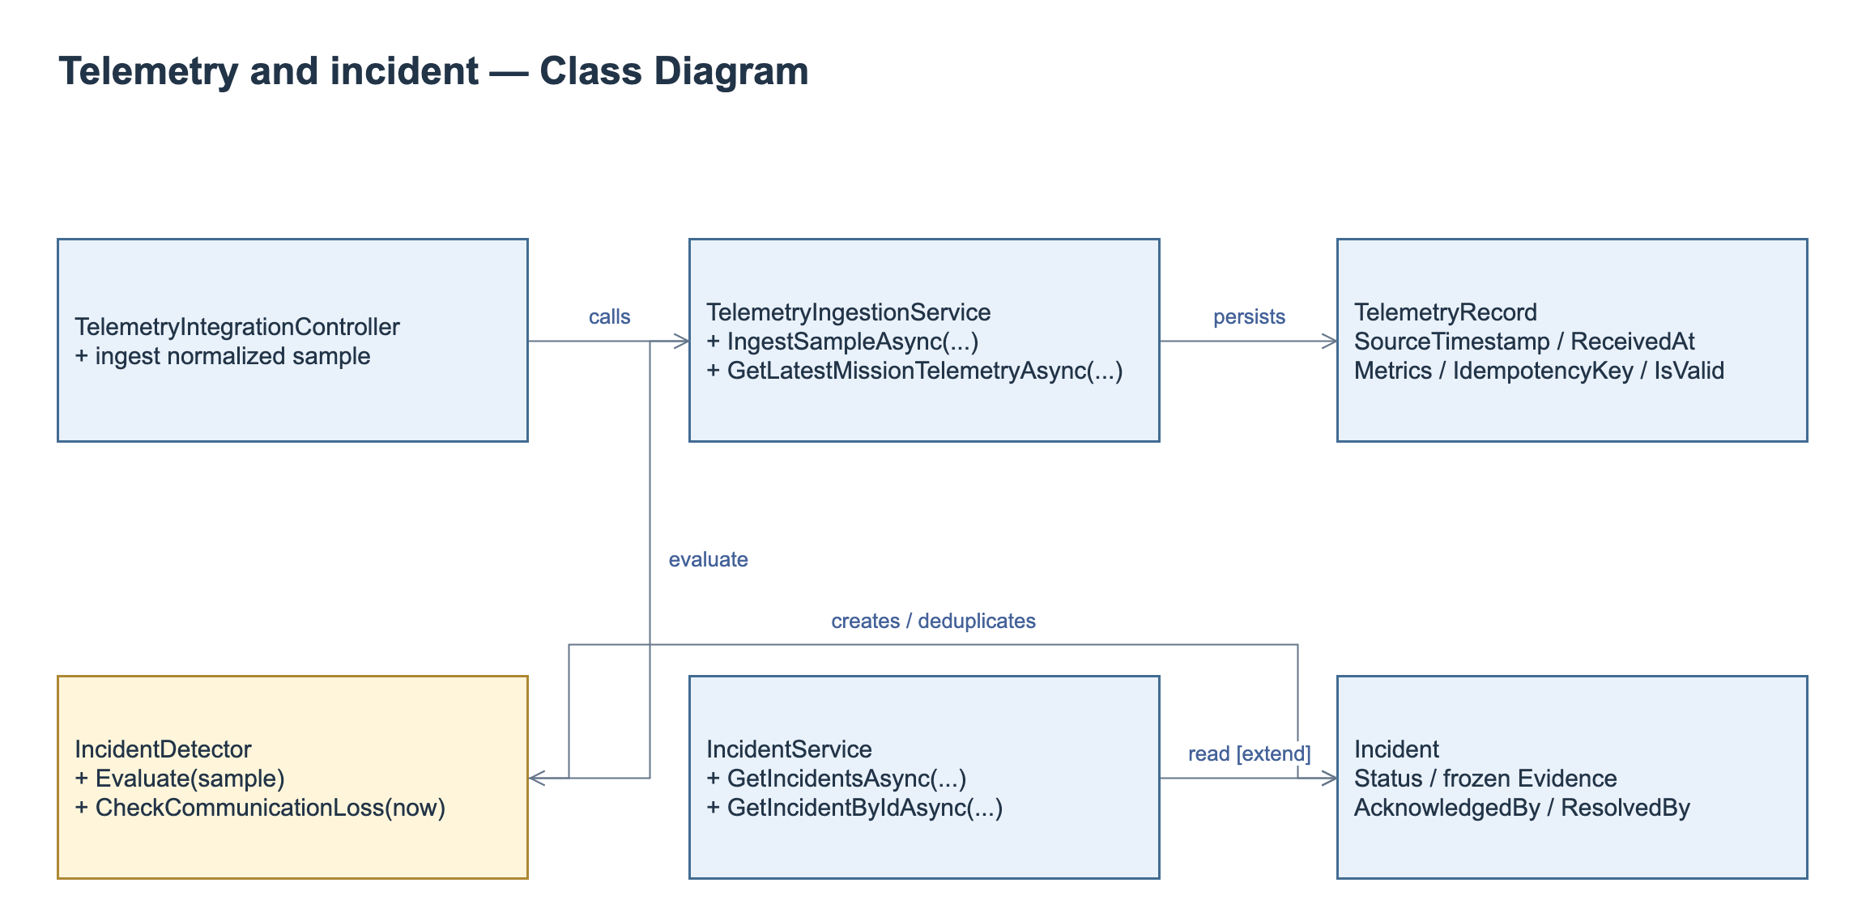
Figure 14. Telemetry and Incident Class Diagram.
Class Specifications
No | Class / Operation | Specification
1 | TelemetryIngestionService.IngestSampleAsync | Check integration authentication upstream, idempotency, UAV/mission association and source/received timestamps. Persist valid/invalid classification; avoid replacing latest by older out-of-order data.
2 | Latest / SSE | Authorize scope, send latest snapshot and incident feed; FE shows unavailable/null/stale. Current sequence IDs reset per connection; durable replay is not promised. Reconnect resynchronizes snapshot and alerts.
3 | IncidentDetector / timer | Evaluate battery, altitude and speed against configured unit-aware rules. An independent timer checks communication loss. Rule recovery conditions determine when a new abnormal episode may create another incident.
4 | Acknowledge / resolve | Enforce current state, actor and Manager-only resolution with reason; persist frozen source evidence and append-only timeline. Reject conflict, duplicate or out-of-scope mutation without changing evidence.

3.2.2 Ingest and Monitor Telemetry
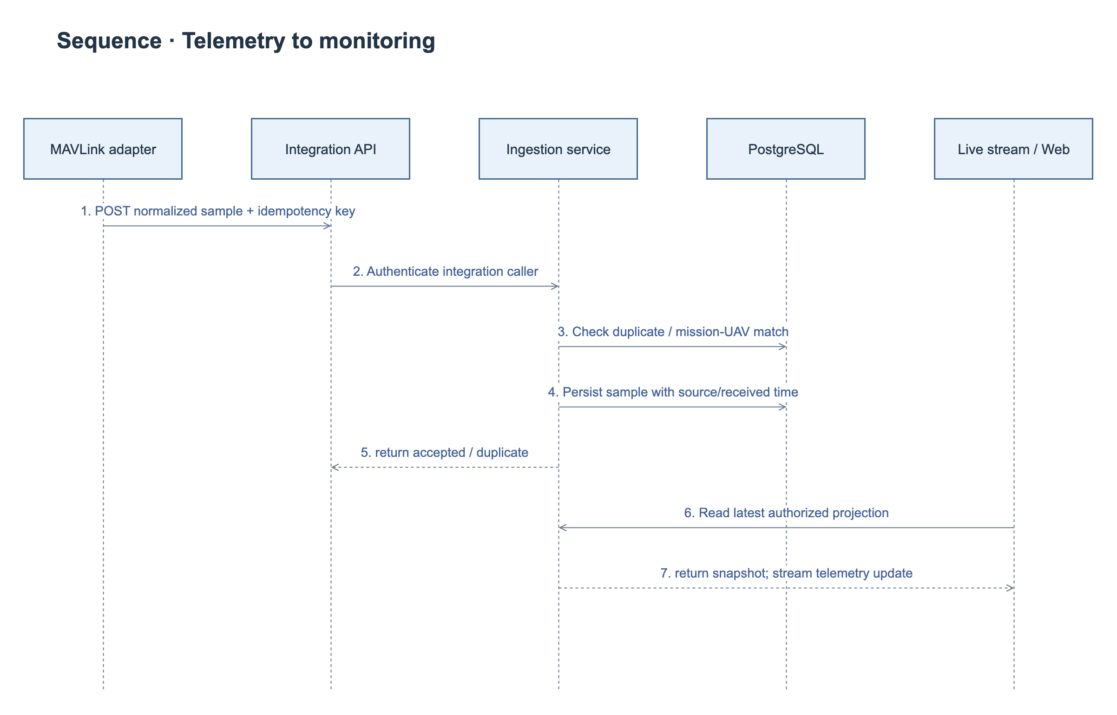
Figure 15. Telemetry Ingestion Sequence Diagram.

3.2.3 Acknowledge and Resolve an Incident
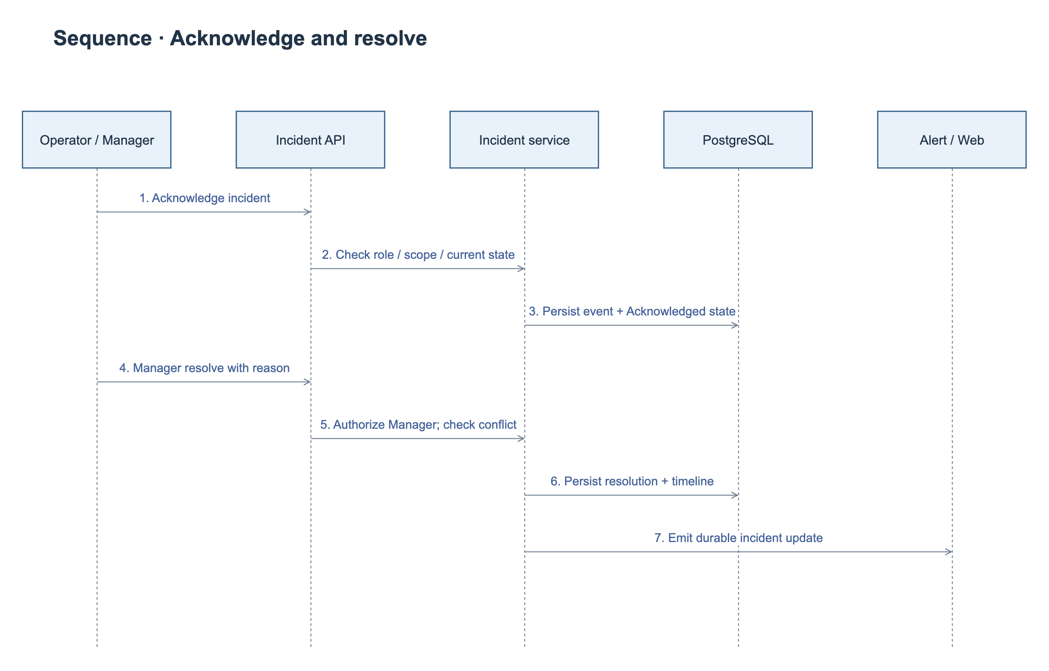
Figure 16. Incident Handling Sequence Diagram.
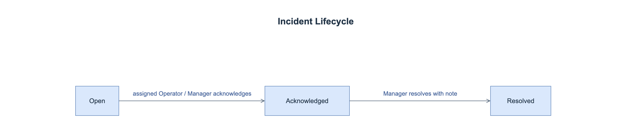
Figure 17. Incident State Diagram.

3.3 Post-flight History and Reporting
PostFlightService provides history queries, report generation, telemetry playback, mission incidents and operational analytics. Aggregation uses authorized persisted samples and UTC coverage windows. Missing metrics remain null. Mission completion follows the external execution event; it is not a browser flight-control command.

3.3.1 Class Diagram
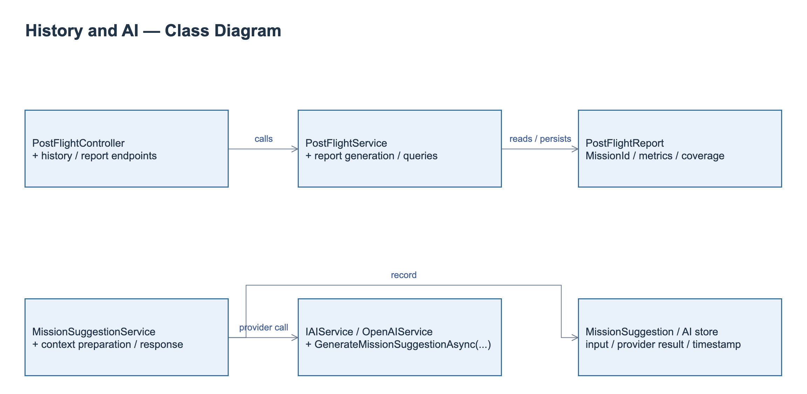
Figure 18. History, Reporting and AI Class Diagram.
Class Specifications
No | Class / Operation | Specification
1 | PostFlightService.GetFlightHistoryAsync | Queries scoped mission history with date, UAV and status filters and pagination.
2 | PostFlightService.GetReportByMissionIdAsync | Returns the persisted report, source mission, coverage and metrics; missing measurements remain unavailable.
3 | PostFlightService.GetTelemetryPlaybackAsync | Returns authorized ordered telemetry positions and timestamps for recorded-route playback.
4 | PostFlightService.FinalizeAndGenerateReportAsync | Processes the authorized completion context and aggregates persisted telemetry and incidents into the mission report.

3.3.2 Retrieve a Post-flight Report
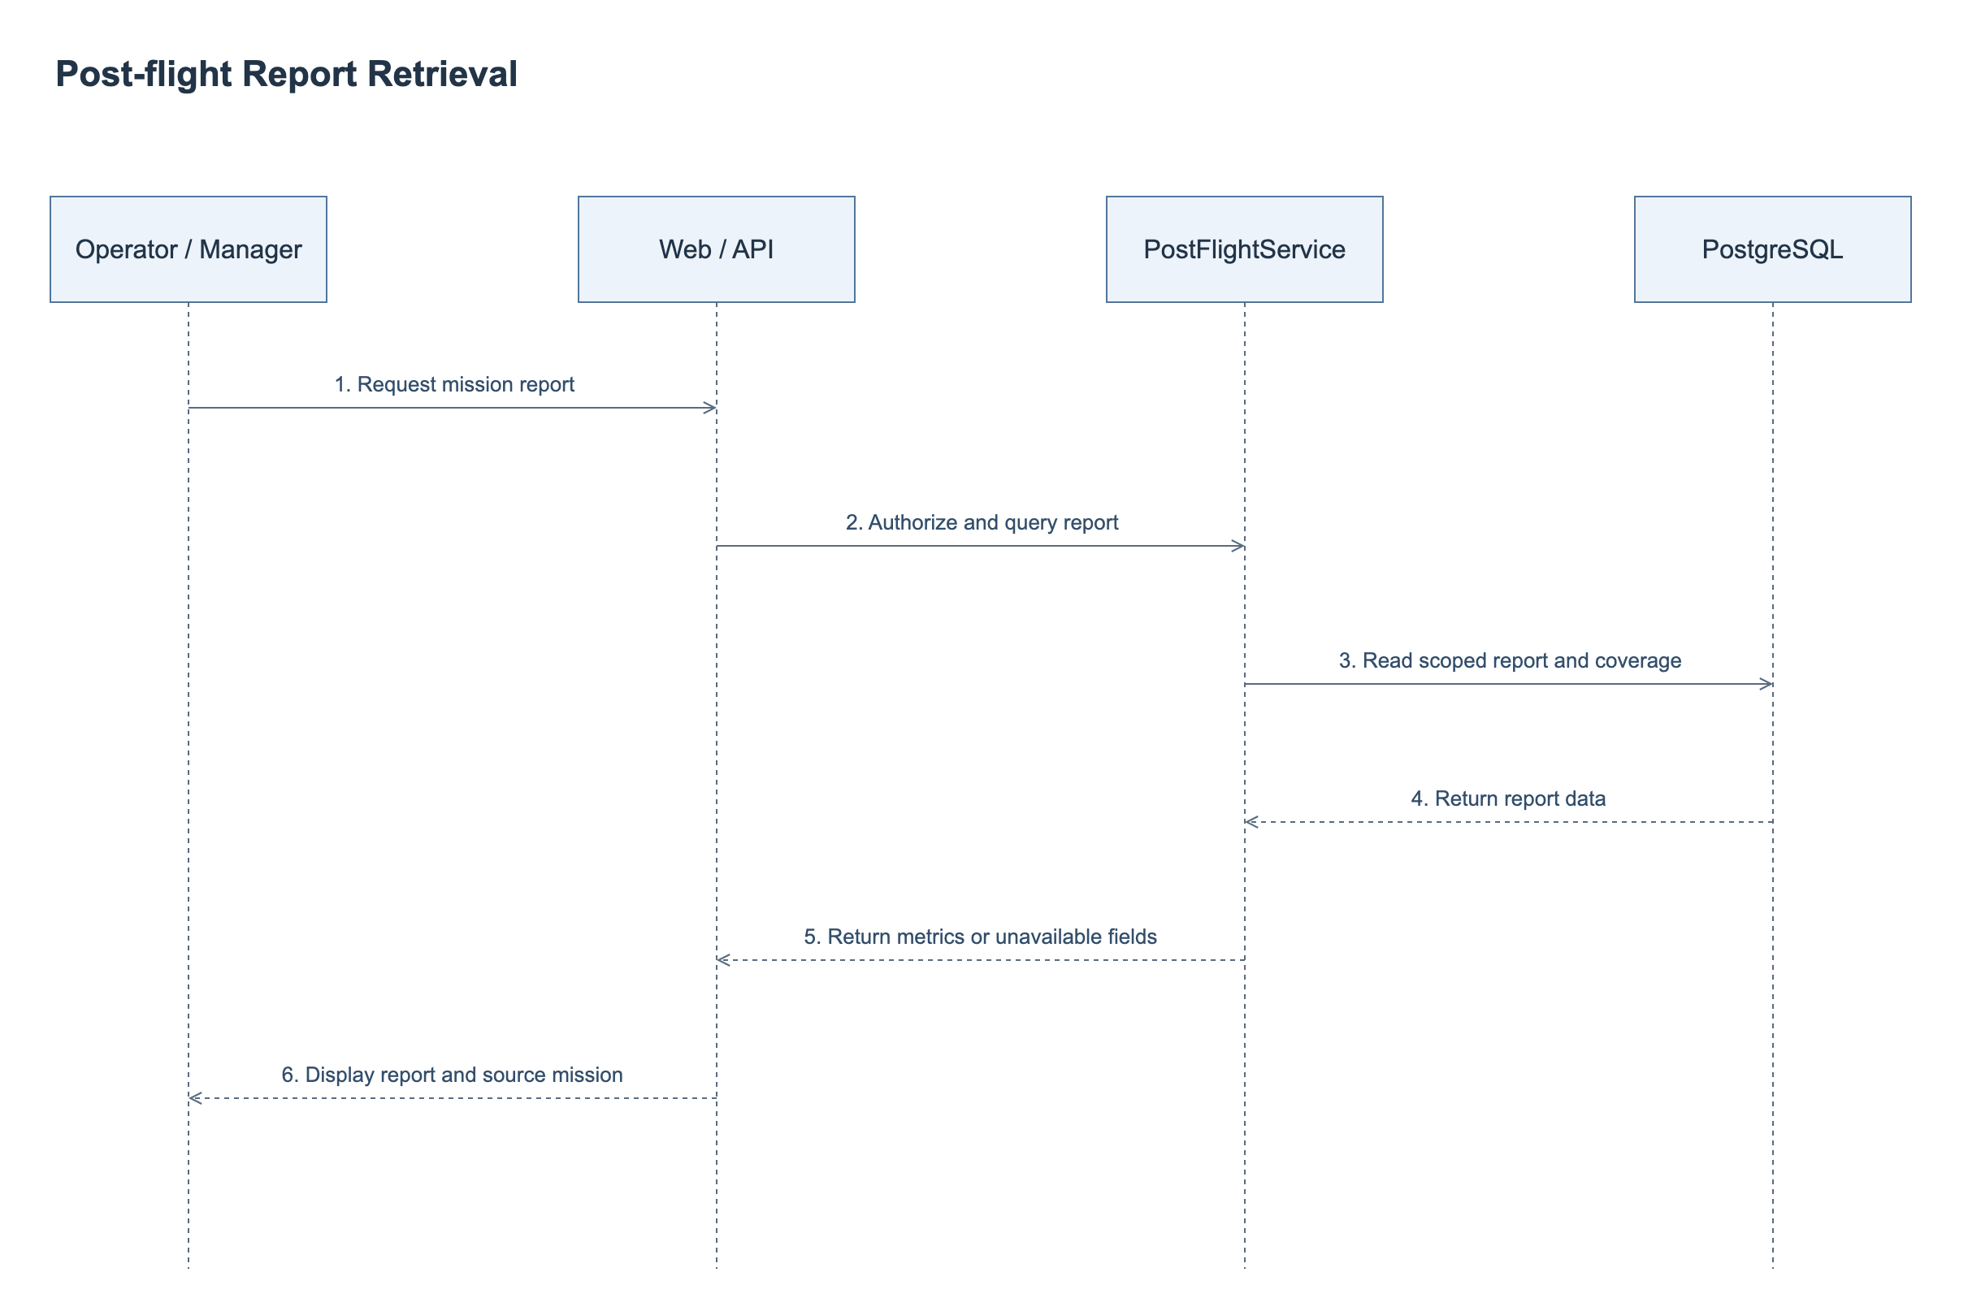
Figure 19. Post-flight Report Retrieval Sequence Diagram.

3.4 AI-assisted Mission Assessment
IAIService.GenerateMissionSuggestionAsync and OpenAIService provide the external AI adapter. MissionSuggestionService prepares and persists mission or update-request context, provider identity, timestamp and assessment outcome. Timeout, rate-limit and invalid-response handling return an unavailable result without changing mission approval. AI output remains advisory.

3.4.1 Class Diagram
The AI assessment classes and their relationships are included in Figure 18. Post-flight reporting and AI assessment share mission and operational evidence; their service responsibilities are specified separately below.
Class Specifications
No | Class / Operation | Specification
1 | MissionSuggestionService | Authorizes and prepares mission or update context, calls the configured adapter and persists the assessment outcome.
2 | IAIService.GenerateMissionSuggestionAsync | Defines the provider contract for an advisory mission assessment.
3 | OpenAIService | Sends bounded authorized context and handles provider timeout, rate limit and invalid responses.

3.4.2 Request an AI Assessment
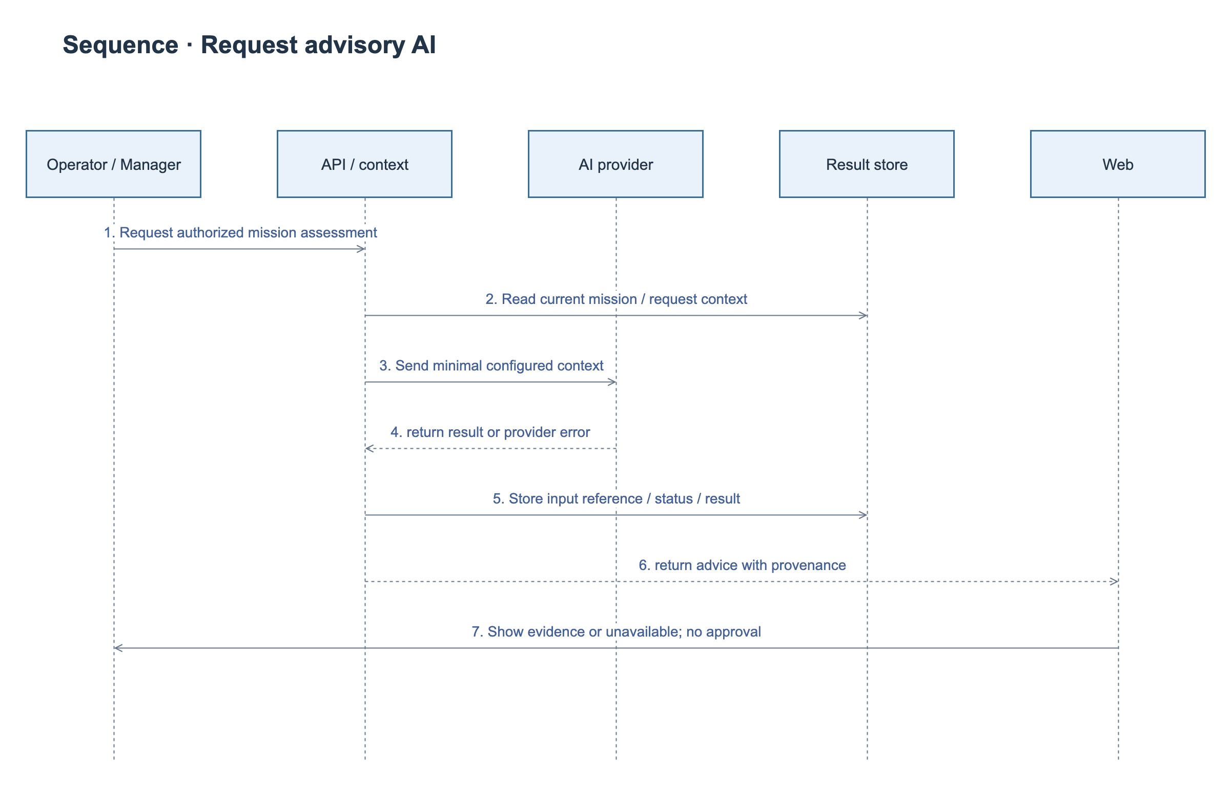
Figure 20. AI Assessment Sequence Diagram.

